Assignment 5 – Reading Data Files

Once you have your program working, you will show Mr. Colwell the program and run it on your screen for evaluation.

Note: To solve the problems, you may need to create a flowchart, or pseudo-code. You will also need to recall the work with strings, and lists.

1. 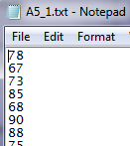You will save a text file named “averages.txt” which is located on Edline under assignments. It contains 100 marks, that you need to get an average. Write a script that will load the A5_1.txt file, calculate the average value, and display the average on the screen.
2. 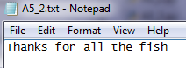Your manager of coding gives you a special task. He asks you to create a very special new language to talk to dolphins. He figured out that every word spoken to a dolphin needs to have a ‘squ’ added before it, and ‘eee’ after it. He sent you a file called A5_2.txt which has a speech that he wants converted to Dolphinese. Write a script that will load the file, converts the text to Dolphinese, and print the results on the Python shell screen.

E.g. ‘Thank you’ 🡪 ‘squThankeee squyoueee’

1. 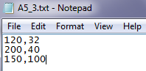Mr. Colwell wants you to draw a triangle in a graphics.py window. He has sent you the points of the triangle by a text file. The text file looks like the one shown, and is also located on Edline called A5_3.txt. Make a program that reads the coordinates and displays the triangle on the screen.